Text industries English

https://intelblast.com/industries/
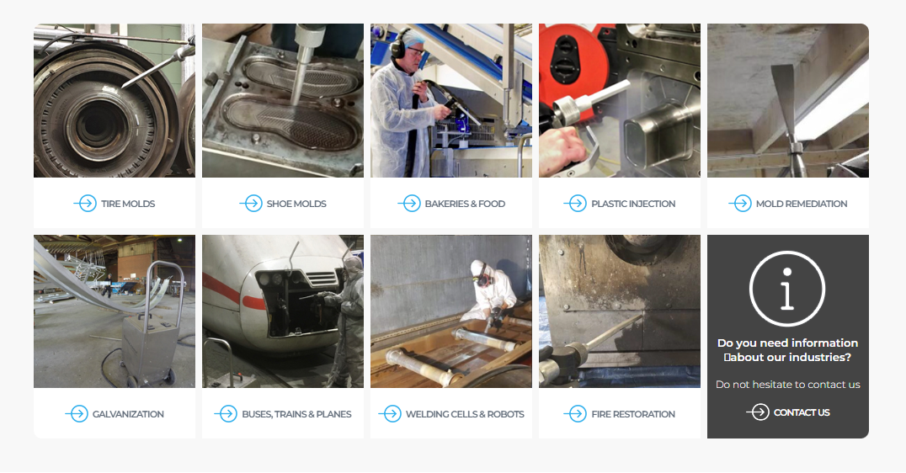

Tire molds https://intelblast.com/industries/tire-molds/

Mold Cleaning: On-Site Efficiency

Efficient on-site cleaning of molds, without the hassle of removal, is a game-changer. Cleaning while the molds are hot offers a distinct advantage for dry ice cleaning. It ensures a rapid return of equipment to production, eliminating the need for cooling and reheating processes.

What typically consumes hours can now be accomplished within minutes.
Cleaning at elevated temperatures minimizes downtime.
On-site cleaning also reduces downtime.
Achieving 100% cleanliness results in fewer rejects.
It's eco-friendly with no chemical usage.
Lower labor costs, safe, and zero secondary waste.
Given the substantial investment in each tire mold, longevity is paramount. Dry ice blasting has stood as the preferred mold cleaning method for the past three decades due to its speed, efficiency, dry nature, and, most importantly, its track record of preserving these valuable molds without any damage.
The impressive impact speed and CO2 expansion upon contact enable the effective cleaning of critical vent holes within molds.

Shoe mold https://intelblast.com/industries/shoe-molds/

SHOE MOLD CLEANING

Preserving the longevity of molds is a paramount concern for all manufacturers. By utilizing dry ice blasting for routine shoe mold cleaning, it ensures optimal asset management and, in turn, reduces capital expenditures.
Molds for all types of shoes or boots necessitate immaculate cleaning to guarantee the highest levels of quality in both performance and appearance.
Dry ice blasting offers a dry and dust-free cleaning solution, all without the need to remove the mold from the production line.
A gentle and non-abrasive removal of deposits from the mold ensures its extended lifespan, thereby reducing the capital expenditure associated with acquiring new process equipment.
The reduction in the use of chemicals or other potentially harmful processes can be substituted with the environmentally friendly dry ice blasting solution.

Bakeries & Food https://intelblast.com/industries/bakeries-food/

BAKERIES & FOOD

Bakeries have compelling reasons to opt for dry ice cleaning:

Zero Downtime: The process line remains consistently dry and production-ready, minimizing downtime
Label and Glue Removal: Effective removal of labels and adhesive residue from conveyors and machines.
Partial Cleaning: The ability to clean specific areas without the need for a full shutdown.
Comprehensive Cleaning: Roof-to-floor cleaning, including lamps, cables, and more, all accomplished without the need for covering materials, ensuring a dry environment.
Machine Interior Cleaning: Precise cleaning inside machines, around bearings, motors, electrical components, and more.
Dry ice, which is the solid form of liquid carbon dioxide, is widely recognized in the food industry for its exceptional cooling properties.
Dry ice is widely accepted as an environmentally friendly technology capable of replacing the use of chemicals and excessive water. Its low moisture content effectively eliminates the presence of bacteria and mold.

Plastic injection https://intelblast.com/industries/plastic-injection/

**DRY ICE BLASTING IN PLASTIC INJECTION MOULDING**

Dry ice blasting stands as the quickest method for eliminating a degraded release agent from the interior of a plastic injection mold press. It excels in completely removing contaminants, even in challenging-to-reach areas like crevices within the tool.
Dry ice blasting is versatile and effective for cleaning various substances and materials, including:

- Release agents
- Overspray
- Hardened plastic
- A combination of all used materials and substances
The advantages of using dry ice blasting in the plastic industry are numerous:

Mold Preservation: Dry ice blasting preserves the integrity of the mold, resulting in a longer mold lifetime and reduced costs.

Labor Cost Reduction: Reduced labor requirements for cleaning processes.
Surface Protection: It prevents damage to the finished product surface, thereby lowering waste and scrap rates.
Dust-Free: Dry ice blasting leaves no dust behind.
No Water Residue: No water residue or moisture left on the cleaned surfaces.
On-Site Cleaning: Cleaning can be conducted in the same location, minimizing downtime and transportation costs.
Efficiency: Dry ice blasting cleans slots and screen vents simultaneously, ensuring thorough cleaning.
Dimensional Stability: Maintains mold surface dimensions without any alterations.
Lower Rejects: A 100% clean mold results in fewer rejected products.
Cleaning the Unseen: It effectively cleans areas that may not be readily visible or accessible.
Dry ice cleaning is highly advantageous for cleaning molds, screws, mixers, and other equipment in the plastic and styrofoam injection industries. It offers a multitude of benefits in these applications, such as efficiency, environmental friendliness, and the preservation of equipment integrity.
Performing on-site cleaning without the necessity of removing molds from the plastic injection molding machine offers several advantages. Cleaning while the equipment is hot is a notable benefit of dry ice cleaning, allowing for a swift return to production without the need for cooling and reheating.
What might typically consume hours can now be accomplished within mere minutes.
Frequent cleaning not only reduces the duration of each cleaning operation but, more importantly, it also minimizes reject rates to the bare minimum.
Achieving a superior finish and quality is possible without the use of dust, water, or chemicals.

Mold remediation https://intelblast.com/industries/mold-remediation/

MOLD REMEDIATION USING DRY ICE

The presence of mold and bacteria in everyday living and working spaces can lead to a host of health issues. Dry ice proves to be an effective solution for mold remediation.
Common causes and habitats for mold growth encompass floods, leaks, plumbing issues, high humidity levels, and inadequate cleaning. With the increase in allergies, the prevalence of fungal infections, and the potential for contamination, mold has become a risk in production facilities, restaurant kitchens, and product and food storage facilities. Addressing these concerns through effective mold remediation is crucial.
Dry Ice Blasting offers a comprehensive solution by not only eliminating existing mold but also removing the matter that can promote future mold growth. This is achieved through dry ice blasting at freezing temperatures as low as -78ºC.
The restoration of contaminated materials is particularly successful in various industries, including residential building, construction, and processing plants. It not only saves time and money but also eliminates the need for disassembly, thereby reducing secondary waste cleanup. This approach focuses on restoring materials rather than replacing them, offering significant cost and resource-saving benefits.
The advantages of Dry Ice Blasting are evident, and they include:

Efficiency: Job completion is 60% to 80% faster.
Safety: It provides a safer, cleaner, and easier cleaning method.
Precision: Offers superior detail cleaning, even in tight spots and around obstructions.
Comprehensive Mold Removal: Ensures complete removal of mold from tight angles, trusses, joists, and corners.
Gentle on Structures: Enables cleaning around wiring and plumbing without causing damage.
Mold Spore Removal: Thoroughly eliminates mold spores.
Easy Cleanup: Leaves minimal waste for disposal.
Dry and Contaminant-Free: Surfaces are left completely dry, free from contaminants, and structurally intact.

Galvanization https://intelblast.com/industries/galvanization/

ZINC ASH REMOVAL

When it comes to the removal of zinc ash from hot-dip galvanization, dry ice blasting offers several key advantages:

Labor Cost Reduction: Done in minutes.
Aftertreatment Improvement: It helps mitigate aftertreatment issues associated with zinc ash.
Tool-Friendly: The process avoids scratching or damaging surfaces with tools, ensuring a gentle yet effective removal.
Dry ice blasting presents a completely dry and non-damaging cleaning process with several benefits, including:

Efficient Ash Removal: Swiftly removes zinc ashes and other unwanted particles.
Hot Surface Cleaning: Capable of cleaning surfaces while they are hot.
No Water Spillage: Eliminates the risk of water spillage in the production area.
Rapid Turnaround: Facilitates a quick turnaround for operations.
Minimal Air Supply: Achieves excellent results with only a minimal air supply.
The removal of spots with zinc ashes is accomplished in a matter of seconds without causing any damage to the surface. The convenience of mobile units that can be utilized at multiple locations, where standard compressed air connections are available, enhances the efficiency of the process. Moreover, the use of dry ice blasting ensures a superior finish and quality without the need for water or chemicals.

Buses, Trains & Planes https://intelblast.com/industries/buses-trains-planes/

BUSES, TRAINS & PLANES CLEANING

In the seamless operation of transportation vehicles such as buses, trains, and planes, proper maintenance of systems and technology is absolutely essential.
Cleaning electrical control panels, air-conditioning/heating systems, seats, and other components with dry ice provides numerous advantages, including:
Reducing Risk: It helps reduce the risk of shortcuts and breakdowns in the systems.
Component Protection: Minimizes the risk of damage to critical components during cleaning.
Electrical Control Systems: Effective cleaning of electrical control systems.
Pre-Inspection: Provides a quick pre-cleaning option before inspections.
HVAC Systems: Cleaning of air conditioning and heating systems.
Suspension Components: Cleaning of springs and shock absorbers.
Brakes and Undercarriage: Ensures clean and well-maintained brakes and undercarriage.
Air Quality: Improves air quality inside transportation vehicles like trains, buses, and airplanes.
Fire Safety: Cleaning exhaust hoods and fans to reduce the risk of fires, particularly in kitchens or food service areas.

Overall, dry ice cleaning contributes to the safe, efficient, and reliable operation of transportation systems while enhancing passenger comfort and safety.

Welding cells and robot cleaning https://intelblast.com/industries/welding-cells-robots/

WELDING CELLS AND ROBOT CLEANING

Critical process cleaning is an indispensable aspect of the automotive manufacturing industry, particularly when it comes to welding cells and robots. Ensuring that these critical components are clean and free from contaminants is essential for maintaining high-quality manufacturing processes and product quality. Dry ice cleaning provides an efficient and thorough method for achieving this critical cleaning in automotive production, contributing to improved product consistency and process reliability.
Regular maintenance of automated production equipment is key to achieving the volume and quality required by manufacturing industries. To this end, having a customized integrated cleaning and preventative maintenance program in place and diligently monitored is essential. Such a program helps extend the life and service of assets, promoting efficiency, reliability, and overall success in manufacturing operations.
Challenging contaminants that can be produced during the production process include, but are not limited to:

- Grease
- Carbon
- Weld slag
- Weld spatter
- Resin
- Glue
- Chemical residues

Effectively managing and removing these contaminants is crucial for maintaining the integrity of production equipment and ensuring product quality in manufacturing industries.
The regular removal of the mentioned contaminants is essential in preventing the buildup that can damage wrist axis joints, clamps, grippers, locating pins, and part presence sensors around automated equipment. Neglecting to do so can lead to costly downtime and the need for technicians to remove accumulated slag and dirt before repair work can commence. Timely maintenance and cleaning procedures are crucial to minimize disruptions and maintain the operational efficiency of automated equipment in manufacturing settings.
Indeed, a "NO CONTACT CLEANING SYSTEM" offers significant advantages for all automated equipment. This approach not only prevents wear and tear on sensitive components but also ensures a thorough and efficient cleaning process without the risk of damage, ultimately contributing to the longevity and consistent performance of the equipment.
Lightweight materials used to manufacture Gun Heads, Grippers, and Tooling Stations are damaged by traditional methods of Slag and Debris removal. Dry Ice provides for the removal of problem causing contaminants without damage to the equipment.
Dry ice cleaning offers a more efficient and environmentally friendly alternative to conventional cleaning methods, eliminating the need for scraping, chiseling, hammering, or the use of toxic chemical cleaners. This approach is not only safer for the environment but also more gentle on the equipment and surfaces being cleaned, ensuring a thorough and damage-free cleaning process.
The efficiency of manufacturing processes is significantly improved with dry ice cleaning, as it restores components like grippers, welding guns, locating pins, and tooling stations to their original working condition. Moreover, during breakdowns or maintenance, engineers can quickly isolate and repair defective equipment without the arduous task of removing stubborn weld slag. This streamlined approach minimizes downtime, maximizes equipment performance, and ultimately enhances overall operational efficiency in manufacturing.

Fire restoration https://intelblast.com/industries/fire-restoration/

Fire restoration is a critical application where dry ice cleaning proves highly valuable. By not introducing additional water or chemicals to the affected areas, it ensures the preservation of sensitive components. The use of crushed dry ice pellets at low pressure allows for the gentle cleaning of even fine electronics without causing damage. Furthermore, dry ice cleaning is effective in removing chlorides that may have migrated with smoke, thus mitigating the risk of rapid corrosion on both external and internal metal parts, including electronics. This makes dry ice cleaning an excellent choice for fire damage restoration, aiding in the recovery of damaged properties while safeguarding valuable equipment and electronics.
Dry ice cleaning has the added benefit of reducing or even eliminating burnt smells and bad odors. It effectively removes residue and contaminants responsible for these odors, contributing to a fresher and more pleasant environment during fire restoration and cleanup processes.
Indeed, dry ice cleaning is a versatile method that can be adjusted to different pressure levels. At higher pressures, it can effectively remove charred surfaces, while at lower pressures, it's gentle enough to clean sensitive components. This flexibility allows for the removal of smoke and soot from various surfaces, including wiring, electrical boxes, ductwork, plumbing, conveyors, motors, and more. The significant advantage is that this can be achieved without introducing secondary waste or causing damage to the surfaces being cleaned, making dry ice cleaning a highly adaptable and efficient choice for fire restoration and cleanup.
The benefits of using dry ice cleaning for fire restoration are extensive:

No Mess: Avoids the mess associated with soda or sand blasting.
No Hazardous Chemicals: Eliminates the need for hazardous chemicals, making it an eco-friendly option.
Odor Reduction: Reduces the burnt smell from fires, contributing to a more pleasant environment.
No Secondary Waste: There is no secondary waste generated, simplifying cleanup.
No Water Damage: The process doesn't introduce additional water damage, preserving structural integrity.
Safe for Electronics: Dry ice cleaning is safe for cleaning electrical components, protecting valuable equipment during restoration.

All of these advantages make dry ice cleaning a superior choice for fire restoration and cleanup efforts.

